Contents

OSD Driver Management 1

Task Sequences 1

Task Sequence Logic 1

Enterprise Driver Packs 2

Other Drivers 2

Install Drivers v2 Script 2

Driver Packages 3

Dev and Prod Logic 3

Dev and Prod File Structure 3

Package Creation 3

Validating Driver Pack File Names 4

Revision History 5

# OSD Driver Management

## Task Sequences

Driver Updates are maintained as Child Task Sequences, for both Prod and Dev instances.

Task sequences are located in the \Software Library\Overview\Operating Systems\Task Sequences\DSK folder.



## Task Sequence Logic

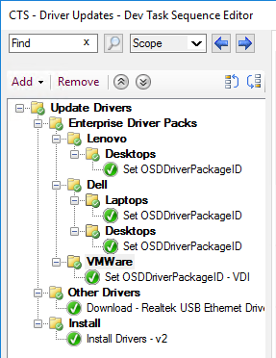

The Driver Child TS is called in the Parent TS after Apply OS

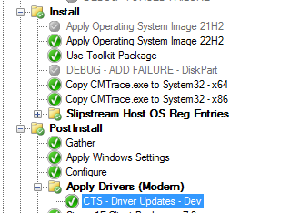

### Enterprise Driver Packs

A Package containing the OEM Enterprise Driver Package for that model is aligned via a Make/Model query.

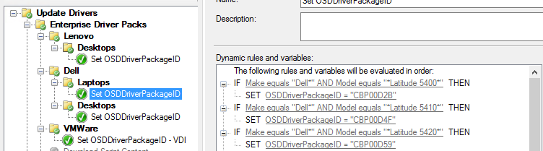

### Other Drivers

Additional Drivers can be implemented here. Content is downloaded to c:\Drivers\other.

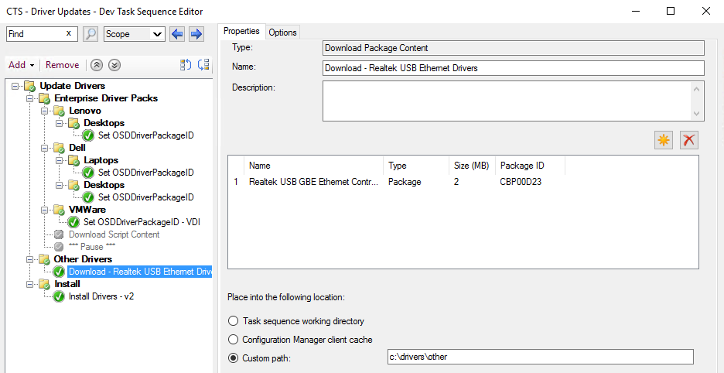

### Install Drivers v2 Script

The Install Drivers v2.x script is responsible for the following operations

* Download Enterprise Driver Package based on PackageID
* Extract information from the Driver Package filename and assign to TS Variables for use in the script or passed onto other functions (Registry Tattoo, Reporting Dashboard, etc)
  + CFGDriverFileName - File Name of Enterprise Driver Pack
  + CFGDriverFileNameFull - Full Path and Name of Enterprise Driver Pack
  + CFGDriverMFG - Manufacturer
  + CFGDriverMake - Make
  + CFGDriverModel - Model
  + CFGDriverWMICModel - WMIC Model (queried from Endpoint)
  + CFGDriverVersion - Driver Version
  + CFGDriverDriverDate - Driver Date (currently queried from local file date)
  + CFGDriverExtension - Driver Extension (exe or cab)
* Extract Enterprise Driver Package to c:\drivers
* Apply DISM /add-driver command to c:\Drivers. Content will include the Enterprise Driver Pack for that model plus any additional drivers downloaded via the “Other Drivers” step.
* Log the process via c:\windows\ccm\smsts\CFG-DriverInstall.log

## Driver Packages

### Dev and Prod Logic

Drivers are not individually versioned by package. The versioning takes place when the Install script parses the filename of the Driver Pack. Package IDs and file locations never change for the lifecycle of a specific model. When a new Driver Pack is released, it should replace the existing driver pack file in Dev and be tested there. Once validated, replace the file in the Prod instance.

### Dev and Prod File Structure

Mirrored Dev and Prod file structures should be configured. The parent folder for each model should align to the WMIC Model query.

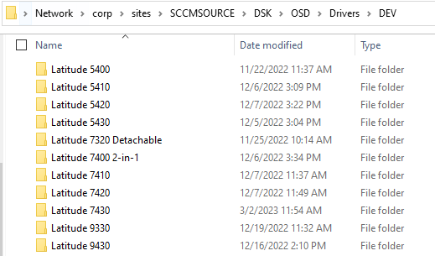

Enterprise Driver Packs live in each Model directory

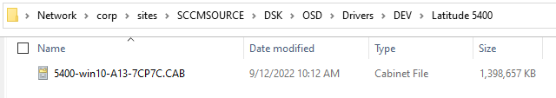

### Package Creation

In the console, Driver packages for Prod and Dev are located at

\Software Library\Overview\Application Management\Packages\DSK\OSD\Drivers

When creating a new Driver package, follow the guidance below

* Name – <WMIC Model>
* Version – Year the Endpoint was released
* Nomad/1E – Enabled
* Do not create a program associated with the package.
* One driver pack per package. If the script sees more than one file, it will fail and note that in the logs.

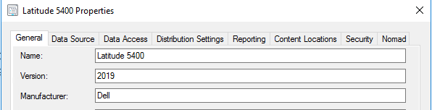

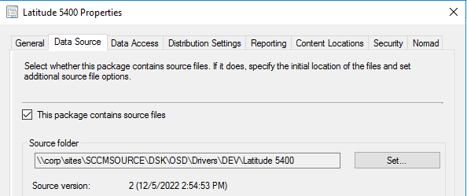

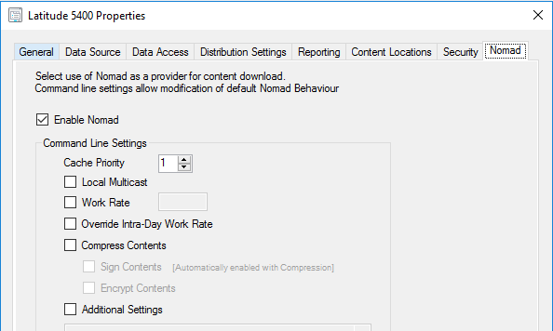

### Validating Driver Pack File Names

The Install script leverages regex match patterns against the Driver Pack filename to help align all the correct variables. The script *CFG Validate Driver Variables.ps1* has been developed to check/validate filenames. It is suggested to run the script against new files. If a filename fails the check, the regex matching in the Install script may need to be adjusted.

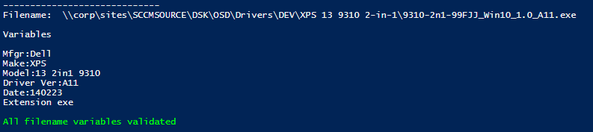

# Revision History

|  |  |  |  |
| --- | --- | --- | --- |
| Date | Version | Details | Author/Contributors |
| 10-Mar-23 | 2.0 | Re-written to align with new Drive Management Technology | DW |